Behavioral Interoperability Modeling Principles and Specification
Contents

1. Scope of this document 1
2. Terms and Definitions 1
3. Behavioral Modeling Requirements and Principles 2
4. Competency Questions (CQs) 3
4.1 CQs for Scenario Behavior Modeling 3
4.2 CQs for Observed Execution Assessment 4
5. Behavioral Interoperability Model 4
5.1 Core Elements of the Behavioral Model 4
5.2 Behavioral Progression 5
6. Behavioral Constraint Model 6
6.1 Types of Behavioral Constraints 6
6.2 Observed Execution Assessment, Formal Representation, and Verdict 7
7. Ontology Requirements 7
7.1 Required Behavioral Concepts 8
7.2 Required Semantic Links and Data Properties 9
7.3 Validation Support 11
7.4 Reuse and Extensibility 12
8. Conclusion 12

1. Scope of this document
This specification defines the behavioral modeling principles, the behavioral model, and the constraint and validation basis for ontology-driven behavioral testing. It covers the representation of behavior, behavioral constraints, and observed execution evidence used for behavioral validation. Such evidence may be derived from raw execution traces, parsed event records, or structured post-processed evidence, provided that the information required for behavioral assessment is preserved. The specification is limited to the concepts, principles, and modeling elements required to support behavioral validation.

2. Terms and Definitions
- IUT: Implementation Under Test, referring in this document to the smart appliance or system being assessed.
- Behavior: Observable execution of the IUT in a given use case or scenario, including relevant state changes, ordering and timing of events, and the resulting operational outcome.
- Behavioral testing: Verification and validation activity used to determine whether the observed execution of the IUT conforms to defined behavioral constraints and achieves the expected operational outcome.
- Behavioral Interoperability Testing Ontology (BITO): Ontology layer used to represent use cases, scenarios, expected behavior, observed execution evidence, behavioral constraints, validation results, and verdicts for ontology-driven behavioral interoperability testing.
- Behavioral constraint: Rule or condition that determines whether the scenario behavior is valid, including state, transition, trigger, ordering, timing, and outcome conditions.
- Trigger/interaction: Event, request, command, signal, or condition that starts, influences, or constrains the execution of behavior in the considered scenario.
- Observed event: Event, request, command, signal, or interaction observed during execution of the considered scenario and used as part of the trace evidence for behavioral assessment.
- Observed execution: Representation of the execution of the considered scenario, including observed events, observed state changes, trace evidence, and related assessment information.
- Observed state change: State change observed during execution, including the observed source state, observed target state, and the element whose state has changed.
- Trace evidence: Observed execution data used for behavioral validation, including relevant events, state observations, timestamps, outcomes, and, where applicable, the associated execution-side interaction context.
- Expected operational outcome: Intended result that the IUT is required to achieve when the scenario is executed under the defined conditions.
- Validation result: Result produced by assessing observed execution evidence against one or more behavioral constraints.
- Verdict: Final or intermediate outcome associated with a validation result, typically expressed as PASS, FAIL, or INCONCLUSIVE.

3. Behavioral Modeling Requirements and Principles
The following principles define the construction of the behavioral model for ontology-driven behavioral testing. The model represents the behavior of the IUT in a defined use case or scenario. It covers the elements needed to represent behavior initiation, behavior progression, and the conditions under which the behavior is valid.

- Scenario identification (P1): The behavior under test shall be defined for an identified use case or scenario.
- IUT and interacting entities identification (P2): The model shall identify the IUT and the external actor or system with which it interacts in the considered scenario.
- State and transition representation (P3): The model shall represent behavior through explicit states and transitions.
- Trigger and interaction representation (P4): The model shall represent the event, request, command, signal, or time event that initiates or influences the behavior.
- Constraint representation (P5): The model shall represent the constraints that determine whether the behavior is valid, including transition conditions, state invariants, ordering constraints, and timing constraints. Where applicable, preconditions and postconditions may also be represented.
- Semantic formalization (P6): The behavioral model and the related domain concepts shall be formalized in RDF/OWL. Constraints shall be specified in SHACL and, where required for trace-dependent or temporal conditions, complemented by SPARQL.
- Reuse and extensibility (P7): The modeling basis shall support reuse across scenarios and extension to additional use cases without modification of the core concepts.
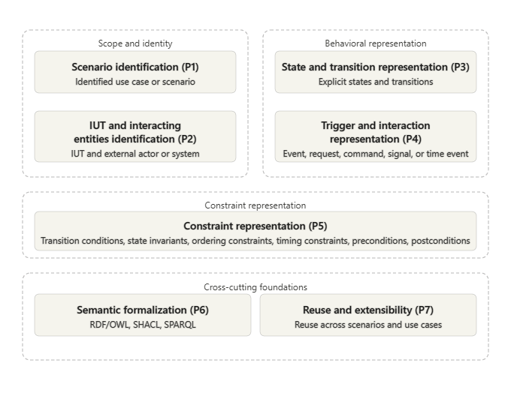

Figure 1: Behavioral modeling principles (P1-P5) with cross-cutting foundations (P6-P7)

Together, these principles define the basis for a behavioral model. The scenario and participating entities define the context, the states and transitions define the behavior, the triggers and constraints define how that behavior is represented, and the semantic formalization ensures consistent representation. Where relevant for behavioral assessment, the represented context may include both the triggering interaction from the execution side and the corresponding observed behavior of the IUT, so that the issued action and the observed response can be interpreted together.

4. Competency Questions (CQs)
The competency questions define what the behavioral model of the considered use case and its scenarios shall represent and what observed execution data shall make it possible to assess. They are used to check that the scenario behaviors of the considered use case are modeled correctly, and that the observed behavior of the IUT can be evaluated against the defined behavioral constraints and the expected operational outcome. Additional competency questions may be introduced in the future if required by the considered use case, scenario, or validation scope.

4.1 CQs for Scenario Behavior Modeling
- CQ1: What is the considered use case and scenario?
- CQ2: What is the IUT in the considered scenario?
- CQ3: Which external actor or system interacts with the IUT in the scenario?
- CQ4: Which states and transitions define the behavior of the IUT in the scenario?
- CQ5: Which trigger or interaction initiates or influences the behavior?
- CQ6: Which behavioral constraints apply to the scenario behavior?
- CQ7: What is the expected operational outcome of the scenario?

4.2 CQs for Observed Execution Assessment
- CQ8: Which events were observed during execution of the scenario?
- CQ9: In what order did the observed events occur?
- CQ10: Which timestamps are associated with the observed events or state changes?
- CQ11: Which state changes were observed during execution?
- CQ12: Which observed execution data is available as trace evidence?
  - CQ12a: Does the available observed execution data preserve both the relevant execution-side interaction context and the corresponding observed behavior of the IUT for the considered scenario?
- CQ13: Does the observed execution satisfy the defined behavioral constraints?
- CQ14: Does the observed execution achieve the expected operational outcome?
- CQ15: What verdict is derived from the available trace evidence?
These competency questions define the information required to model the scenario behavior and to assess its observed execution within the scope of this specification. The competency questions are also used as a validation basis for checking the coverage of the ontology. They can be operationalized through SPARQL queries over the RDF representation and through DL queries in Protégé/HermiT to verify that the required classes, individuals, and semantic relations are represented.

5. Behavioral Interoperability Model
The behavioral model defines the expected behavior of the IUT for a considered use case or scenario. It provides a structured representation of the scenario context, the behavior execution, the expected state progression, and the resulting scenario state under the defined conditions. It is limited to the elements required to represent the expected scenario behavior. The detailed behavioral constraints are specified in Section 6, and the ontology formalization requirements are specified in Section 7.

5.1 Core Elements of the Behavioral Model
The behavioral model shall represent the following elements:
- Use case/scenario behavior: the behavior under consideration for the identified use case or scenario.
- IUT and interacting actor/system: the IUT and the external actor or system involved in the considered scenario.
- Initial state: the relevant state of the IUT and the considered scenario context before execution.
- Conditions before execution: the conditions that shall hold before the behavior can validly start.
- Triggering interaction/action: the event, request, command, signal, or action that starts or influences the behavior.
- Behavior execution: progression of the IUT behavior in the considered scenario, from the triggering interaction through the expected state change(s) to the resulting scenario state.
- Expected state transition: the state change, or sequence of state changes, expected to occur during execution.
- Resulting state: the relevant state of the IUT and scenario context after execution.
- Conditions after execution: the conditions that are expected to hold after execution.
Where relevant for the considered scenario, these elements may later be linked to observed execution evidence that preserves both the execution-side interaction context and the corresponding observed behavior of the IUT. The behavioral model may also represent intermediate states, waiting states, or additional behavior steps where such representation is required by the scenario. The formal ontology representation of these behavioral model elements is specified in Section 7.

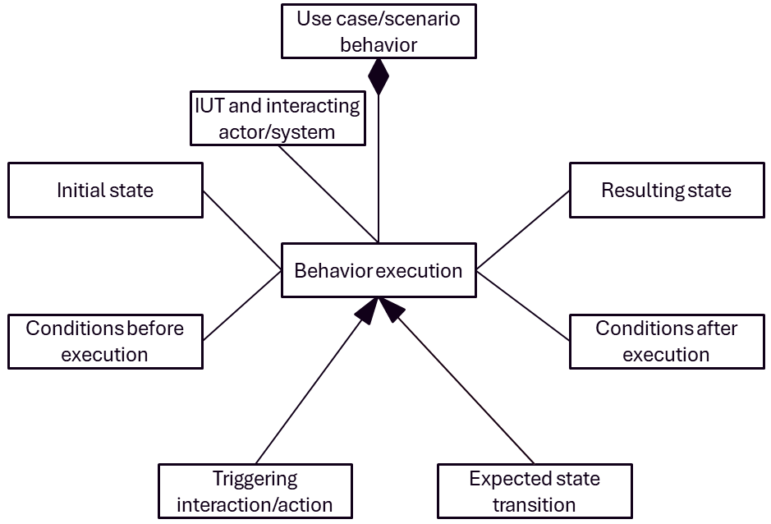
Figure 2: Core elements of the behavioral model

Figure 2 shows the main elements used to represent the expected behavior of the IUT for a considered scenario. The use case or scenario behavior defines the behavioral context. The IUT and interacting actor/system identify the participating entities. The initial state and the conditions before execution describe the situation before execution starts. The triggering interaction or action initiates the behavior, and the expected state transition represents the change that the behavior is expected to produce. The resulting state and the conditions after execution represent the expected situation after execution.

5.2 Behavioral Progression
The behavioral model shall represent behavior as a progression from an initial state, under defined conditions before execution, through a triggering interaction or action and one or more expected state transitions, to a resulting state and conditions after execution.

This progression may consist of a single behavior step or multiple connected behavior steps. Where more than one behavior step is represented, the resulting scenario state of one step may provide the context for a subsequent step.
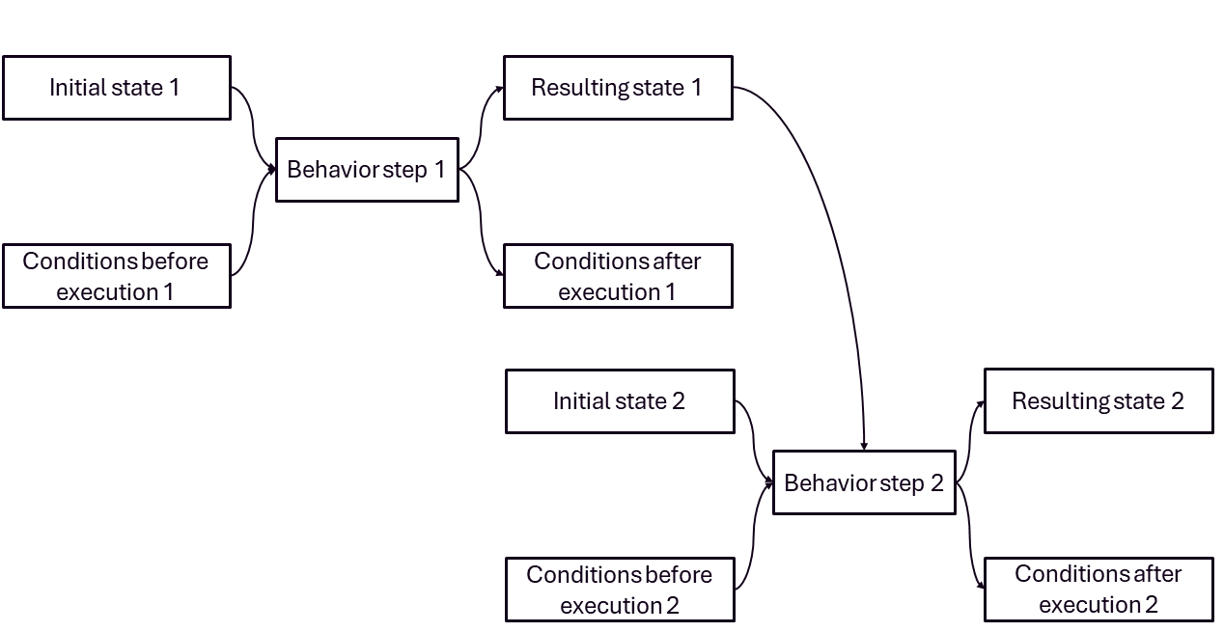

Figure 3: Generic multi-step behavior progression.

Figure 3 shows that a behavioral model may contain more than one connected behavior step. Each step is defined by its own initial state, conditions before execution, resulting state, and conditions after execution. The progression from one step to another makes it possible to represent more complex scenario behavior while preserving a structured and reusable modeling basis.

6. Behavioral Constraint Model
The behavioral constraint model defines the conditions under which the behavioral model defined in Section 5 is valid. It provides the basis for assessing whether the observed execution of the IUT conforms to the expected scenario behavior.

6.1 Types of Behavioral Constraints
The behavioral constraint model shall support the following categories of behavioral constraints:
- State constraints: conditions that shall hold for a behavioral state to be valid.
- Transition constraints: conditions that shall hold for a behavioral transition to be valid.
- Trigger/interaction constraints: conditions that shall apply to the event, request, command, signal, or interaction that initiates or influences the behavior.
- Ordering constraints: conditions that shall apply to the relative order of events, actions, or state changes.
- Timing constraints: conditions that shall apply to timestamps, delays, durations, deadlines, or time windows.
- Outcome constraints: conditions that shall apply to the expected operational outcome.
Conditions before execution and Conditions after execution are represented within these categories, depending on whether they apply before, during, or after behavioral progression. The ontology concepts used to represent these behavioral constraint categories are specified in Section 7.

6.2 Observed Execution Assessment, Formal Representation, and Verdict
Observed events, interactions, state changes, timestamps, ordering relations, outcomes, and other trace evidence shall be checked against the applicable behavioral constraints in order to determine whether the execution conforms to the expected scenario behavior and achieves the expected operational outcome. Observed execution evidence may be derived from execution traces, parsed event records, or structured post-processed evidence, provided that the information required for behavioral assessment is preserved. Where relevant, such evidence may preserve both the execution-side interaction context and the corresponding observed behavior of the IUT.

The behavioral constraints shall be represented using semantic web technologies consistent with the ontology-driven behavioral testing approach. Structural, graph-level, state-related, and transition-related constraints may be represented in SHACL. Temporal, ordering-dependent, and trace-dependent constraints may be complemented by SPARQL where required. This remains consistent with ontology-based behavioral modeling approaches that separate core behavioral constructs from later execution and assessment semantics.

The assessment of the observed execution against the applicable behavioral constraints provides the basis for deriving:
- PASS: where the available trace evidence shows that the observed execution complies with the applicable behavioral constraints.
- FAIL: where the available trace evidence shows that one or more applicable behavioral constraints are violated.
- INCONCLUSIVE: where the available trace evidence is insufficient or ambiguous for reliable assessment.

The assessment output is represented as a validation result associated with the assessed behavioral constraints, the supporting trace evidence, and the derived verdict. The ontology provides the semantic representation basis for these elements, while the executable validation logic is defined separately through SHACL shapes and, where required, SPARQL queries.

7. Ontology Requirements
The ontology shall provide the formal semantic representation needed to support the behavioral model defined in Section 5 and the behavioral constraint model defined in Section 6. It shall reuse existing ontology concepts where their semantics are aligned with the considered behavioral interoperability testing scope, and it shall introduce additional BITO concepts where the required behavioral testing semantics are not sufficiently covered by existing ontologies.
The Behavioral Interoperability Testing Ontology (BITO) provides this additional behavioral layer. It represents use cases, scenarios, expected behavior, observed execution evidence, behavioral constraints, validation results, and verdicts. This makes it possible to connect expected scenario behavior with observed execution evidence and validation outcomes in a single semantic representation.

7.1 Required Behavioral Concepts
The ontology shall support the concepts required for representing and assessing the considered scenario behavior. The BITO ontology reuses concepts from SAREF, SAREF4ENER, PROV-O, and OWL-Time, and introduces BITO specific concepts for behavioral interoperability testing.
The reused SAREF concepts are:
- saref:Appliance
- saref:Device
- saref:PowerUnit
- saref:PropertyValue
- saref:State
- saref:UnitOfMeasure
The reused SAREF4ENER concepts are:
- s4ener:AlternativesGroup
- s4ener:PowerProfile
- s4ener:PowerSequence
- s4ener:PowerSequenceState
- s4ener:Slot
The reused PROV-O concepts are:
- prov:Activity
- prov:Agent
- prov:Entity
The reused OWL-Time concepts are:
- time:Instant
- time:Interval
The BITO-specific concepts are:
- bito:UseCase
- bito:Scenario
- bito:UseCaseFunction
- bito:ExpectedStateTransition
- bito:ExpectedOperationalOutcome
- bito:ObservedEvent
- bito:ObservedExecution
- bito:ObservedStateChange
- bito:TraceEvidence
- bito:BehavioralConstraint
- bito:StateConstraint
- bito:TransitionConstraint
- bito:TriggerConstraint
- bito:OrderingConstraint
- bito:TimingConstraint
- bito:OutcomeConstraint
- bito:BehavioralElement
- bito:StructuralContainer
- bito:StructuralElement
- bito:ValidationResult
- bito:ValidationVerdict
Together, these reused and BITO-specific concepts provide the semantic basis needed to represent the expected scenario behavior, the observed execution evidence, the applicable behavioral constraints, and the validation results derived from the assessment.

7.2 Required Semantic Links and Data Properties
The ontology shall support the semantic links and data properties needed to connect the use case, scenario, IUT, interacting actor or system, expected behavior, observed execution evidence, behavioral constraints, validation results, and verdicts.
The main BITO object properties used for scenario and expected behavior representation are:
- bito:hasScenario
- bito:hasIUT
- bito:hasInteractingActorSystem
- bito:realizedByUseCaseFunction
- bito:hasExpectedStateTransition
- bito:hasSourceState
- bito:hasTargetState
- bito:hasExpectedOperationalOutcome
- bito:hasBehavioralConstraint
- bito:appliesTo
- bito:hasTriggeringInteraction
The main BITO object properties used for observed execution and trace evidence representation are:
- bito:hasObservedExecution
- bito:hasObservedEvent
- bito:hasObservedStateChange
- bito:hasObservedSourceState
- bito:hasObservedTargetState
- bito:hasTraceEvidence
- bito:requestedPowerSequence
- bito:observedSelectedPowerSequence
- bito:observedFormerPreferredPowerSequence
- bito:observedPreferredPowerSequence
- bito:observedOptionalPowerSequence
- bito:observedScheduledPowerSequence
- bito:hasRelevantPowerSequence
The main BITO object properties used for validation representation are:
- bito:hasValidationResult
- bito:validatesConstraint
- bito:basedOnTraceEvidence
- bito:hasVerdict
The ontology also uses the following reused object properties:
- saref:hasState
- saref:consistsOf
- saref:isMeasuredIn
- s4ener:belongsTo
The ontology uses datatype properties to represent identifiers, values, temporal information, evidence attributes, scenario information, and validation attributes. The main reused datatype properties are:
- saref:hasIdentifier
- saref:hasValue
- s4ener:hasStartTime
- s4ener:hasEndTime
- s4ener:hasEarliestStartTime
- s4ener:hasLatestEndTime
- s4ener:hasDefaultDuration
- s4ener:isPausable
- s4ener:isStoppable
- s4ener:nodeRemoteControllable
- s4ener:sequenceRemoteControllable
- s4ener:supportsReselection
- prov:startedAtTime
- prov:endedAtTime
The main BITO datatype properties are:
- bito:useCaseName
- bito:useCaseVersion
- bito:scenarioNumber
- bito:scenarioName
- bito:ucfName
- bito:entityId
- bito:entityType
- bito:observedInteractionKind
- bito:interactionEndpoint
- bito:eventOrderIndex
- bito:requestTimestamp
- bito:requestedStartTime
- bito:acceptedAt
- bito:acceptanceOutcome
- bito:observedAt
- bito:observedPlanUpdatedAt
- bito:observedExecutionStart
- bito:observedExecutionEnd
- bito:observedPlanStatus
- bito:observedRunStatus
- bito:evidenceMode
- bito:evidencePreservesInteractionContext
- bito:evidencePreservesObservedBehavior
- bito:satisfiesConstraint
- bito:achievesExpectedOutcome
- bito:validationMessage
These object and datatype properties are required so that expected behavior, observed behavior, trace evidence, behavioral constraints, validation results, and verdicts can be interpreted within a single consistent semantic structure.
Figure 4 presents a conceptual overview of the Behavioral Interoperability Testing Ontology (BITO). It shows the main reused ontology concepts, the added BITO concepts, and the semantic links required to connect scenario behavior, behavioral constraints, observed execution, trace evidence, validation results, and verdicts.
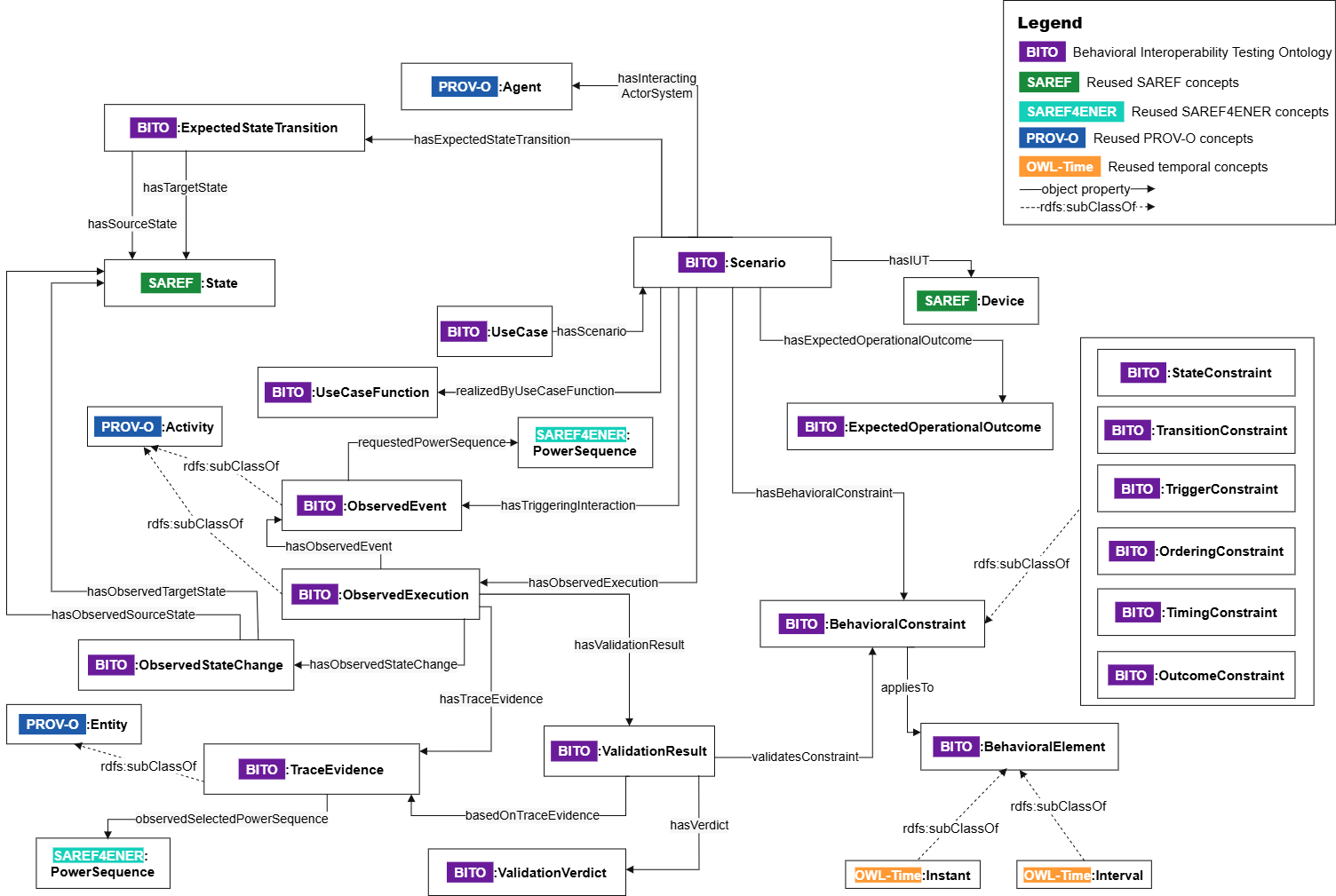
Figure 4: Conceptual overview of the Behavioral Interoperability Testing Ontology (BITO)

7.3 Validation Support
The ontology shall provide the representation basis on top of which validation artefacts are defined. BITO represents the scenario behavior, observed execution evidence, behavioral constraints, validation results, and verdicts. The executable validation logic is defined separately through SHACL shapes and, where required, SPARQL queries.
Accordingly:
- the ontology and related domain concepts shall be represented in RDF/OWL;
- structural, graph-level, state-related, and transition-related constraints may be represented in SHACL;
- temporal, ordering-dependent, and trace-dependent assessment conditions may be complemented by SPARQL;
- validation outputs shall be represented through validation results and linked verdicts, together with the supporting trace evidence and assessed constraints.
This separation is important: BITO provides the semantic representation layer, while SHACL and SPARQL perform the actual constraint checking. The ontology therefore supports traceable behavioral validation, but the executable validation artefacts perform the validation logic.

7.4 Reuse and Extensibility
The ontology shall support reuse across scenarios and extensibility to additional use cases without modification of the core BITO concepts. This is required so that the same ontology-driven behavioral testing basis can be applied to different appliances, scenarios, and validation scopes while preserving a stable semantic structure.
Reuse is supported by aligning domain-specific concepts with existing ontologies such as SAREF and SAREF4ENER, and by using PROV-O and OWL-Time for execution evidence and temporal representation. Extensibility is supported by keeping BITO focused on behavioral interoperability testing concepts, such as scenarios, expected transitions, observed execution, trace evidence, behavioral constraints, validation results, and verdicts.

8. Conclusion
This specification defines the principles for behavioral interoperability modeling, the competency questions that guide behavioral representation and assessment, the behavioral model used to represent expected scenario behavior, and the behavioral constraint model used to determine behavioral validity. It also defines the ontology requirements for the Behavioral Interoperability Testing Ontology (BITO). BITO provides the semantic representation layer for use cases, scenarios, expected behavior, observed execution evidence, behavioral constraints, validation results, and verdicts. This representation supports traceable behavioral assessment by linking observed evidence to constraints and validation outcomes. The executable validation logic is defined separately through SHACL shapes and SPARQL queries. Together, BITO and the validation artefacts provide a reusable basis for ontology-driven behavioral interoperability testing.

